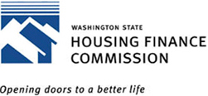

Program News & Updates Mailing list form
This form was designed to help us facilitate our program news and updates with you in mind.
If you wish to be in our database, please take a moment to complete this form and Email it to AskUsMHCF@wshfc.org or Fax it to 206.587.5113.
PLEASE CHECK ONE OR MORE
 Current Year Allocation Information
This includes information about the most current allocation list and our annually updated list of developers.
 Program Information and Activities
This includes public hearing notices, proposed changes to our policies, and updates to our allocation list.
 Primary Organizational Contact
Individuals on this list will receive documents such as Commission reports and other mailings which are typically sent to only one person per organization.
 All of the above
Name*
Organization
Address*
Phone*
Fax
Email*
*required
In the interest of promoting open communication with our stakeholders, we thank you for taking the time to share your preferences with us.
 The MHCF/LIHTC Division

