WSHFC Tenant Engagement Response Form
To support points categories in section 4.5 of the scoring sheet
With the stated goal of financing more developments BY and FOR the community, WSHFC seeks to empower communities to design, develop, manage, and own affordable housing developments in the long term. The first steps include entering communities without causing harm*, identifying potential community partners, and beginning a relationship with the community where developers and Community Based Organizations are accountable to each other.
Important notes for completing the CBO Evaluation Process and completing this form:
- OUTSIDE KING COUNTY: WSHFC staff will interview CBOs to determine eligibility. Applicants must submit the names, contact information and any need for translation services for CBO(s) involved in any aspect of the project as part of the Intent to Apply by December 5, 2024. Staff will contact CBOs and hold interviews between December 6, 2024 and January 24, 2025. Interview questions are in a separate document in the Application Packet titled “2025 CBO Pre-App Interview Questions.”
- IN KING COUNTY: WSHFC staff will interview CBOs to determine eligibility after the tiered pipeline list has been posted. Staff will reach out to applicants for CBO contact information.
- While we do not limit the length of narrative responses in this document; please be as concise as possible, focusing on the specifics of the questions. Please avoid redundancies and gratuitous information. One page of narrative or less should satisfy each section’s requirements.
- Depending on the status of community engagement at the time of application, you may be describing activities that have already taken place, community input that has already been incorporated, or planned activities for the future. All of this information is helpful and should be included.
- Any supporting legal documents such as partnership agreements or MOUs should be clearly labeled and uploaded along with this form.
The Engagement Toolkits posted on our website will help you find processes and recommendations for completing this form. Other organizations developed these toolkits for purposes other than housing—they are guides and resources to help you form your own community engagement plan and should not be taken as step-by-step instructions. Please note: WSHFC policy supersedes any requirement included in the toolkits provided.
Representatives of all members of the General Partnership and of each Community Based Organization or other entity representing the community must e-sign this document.

SECTIONS
Applications taking ANY points under section 4.5 must respond to sections 1 and 2
- Internal Preparation (Developer/Sponsor Organization)
- Identifying, Approaching, and Establishing Relationships with Community
Applications taking points under section 4.5.2 “CBO Inclusion” must respond to section 3:
- Partnering With a Community Based Organization
Applications taking points under section 4.5.3 “Meaningful Community Engagement” must respond to sections 4 and 5:
- Community Engagement Process
- Implementing Community Input

- Internal Preparation (Developer/Sponsor Organization)

Developer/Sponsor Organizations must ensure that they are prepared to engage with community to minimize the potential for unintentional harm* they can cause. More information on internal preparation can be found in the recommended toolkits.
  - Describe the process your organization went through to clarify how your development staff think about the community you are approaching, and how this exercise affected the current community engagement efforts. Include:
    - Implicit Biases*
    - Explicit Biases (diversity among staff, leadership)
    - Stereotypes
    - Past experiences, good and bad

Enter Response to Section 1 here:

- Identifying, Approaching, and Establishing Relationships with Community
Developer/Sponsor Organizations must identify and engage with one or more Communities Harmed by housing disparities, to understand and respond to their specific concerns, issues, and requirements. Please refer to section 4.5 “Projects that are by and for the community” in the policy document to complete the following section.
  - Describe the identity- and/or geography-based Community(ies) Harmed that you are engaging with on this project and why it was chosen, including:
    - The process, research, and sources used to arrive at the decision to focus on this specific community.
    - Specific barriers the community faces in meeting basic needs, accessing services and opportunities.
    - Institutions and other community organizations that exist within or in support of this community.
  - Describe the history of and planned ongoing relationship with the community and representative CBO(s) for the life of the project, including:
    - The process of selecting and forming a relationship with the CBO(s)
    - Roles and responsibilities of each organization (developer/sponsor and any CBOs) as they relate to the community(s) during all phases of the project. This may include communication and engagement, lease up, relocation, property management, space programming, resident services, long term ownership, etc.
    - Methods of accountability for each organization to the community for maintaining relationships, meeting obligations, and fulfilling promises made.

Enter Response to Section 2 here:

- Partnering With a Community Based Organization

  - If you are taking points for section 4.5.2 (CBO Inclusion), please describe the following:
    - Financial Benefits the CBO will receive as a result of this partnership.
    - Service being provided by the CBO that is valuable to community as determined by the community.
    - Non-financial benefits the CBO will receive as a result of this partnership.
  - Please attach any agreements regarding the above.

Enter Response to Section 3 here:

- Community Engagement Process

WSHFC strongly recommends that, if you are not a CBO, that you partner with a Community Based Organization (CBO) to lead the community engagement process.

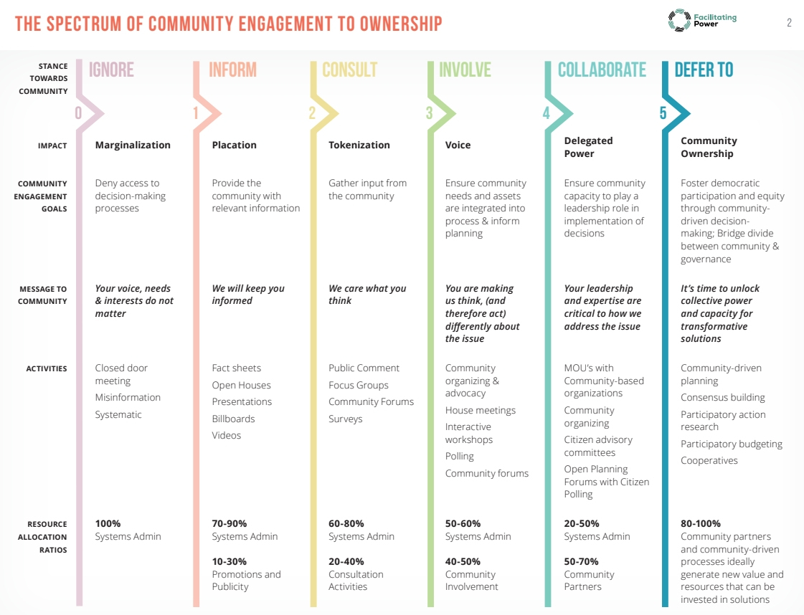
Refer to this descriptive rubric entitled “The Spectrum of Community Engagement to Ownership.” Your engagement plan should include at least some activities in the Involve, Collaborate, and/or Defer To stances towards community.
Image credit: Rosa Gonzalez, Facilitating Power (Spectrum 2-1.pdf (movementstrategy.org))

  - If you are taking any points for section 4.5.3 (Meaningful Community Engagement), whether in partnership with a CBO, contracting with a consultant, or using in-house staff, please describe the Engagement Plan. Include:
    - Goals (quantitative and qualitative) for the engagement process
      - Community’s goals for the engagement process
      - Your goals for the engagement process
      - Shared goals for the engagement process
    - Project decisions that will be made in collaboration with the community. Decisions should be feasible within the project timeline and considered with full budget transparency.
      - How will you arrive at the list of decision points?
      - How will you engage the community in a way that ensures they are informed and empowered for decisions in which they have input (for example, choosing one priority over another, working within a budget)?
    - Methods
    - Timeline
    - Barriers to engagement, both logistic and other, and how they can be overcome (including experiences the community may have had in the past that can contribute to lack of trust in the process)
    - Accessibility*
    - Communication to community about how their involvement is used
    - Simple budget, including compensation* for the CBO or consultant as well as for individual community members and other stakeholders
  - If you are not a CBO and do not plan to work with a CBO to conduct your Community Engagement process, please provide a personal statement from the consultant or staff member who will be leading the process. It should include:
    - previous community engagement work
    - lived experience in a community reflective of the community to be engaged
    - demonstrated commitment to antiracism*

Enter Response to Section 4 here:

- Implementing Community Input
  - Describe your plan for incorporating the decisions reached in collaboration with the community into the project. Depending on where you are in the engagement process at the time of application, you may be describing actual decisions that resulted from community input, or a plan for how you will implement decisions when they are made.
    - How much is budgeted for elements prioritized by the community?
    - How will you be held accountable for implementing the decisions?
  - If a service provider has been or will be contracted to operate within the development, please describe the entity (or type of entity, if none has yet been named) and its connection to the specific Community(ies) Harmed by housing disparities that you have identified.
    - Why was this service selected as one that the community values?

Enter Response to Section 5 here:

TERMS – Definitions and Explanations
Harm: When entering a community for the first time, good intentions are not enough to prevent an organization from harming residents. Ill-informed or insincere engagement can cause far more harm than declining to enter a community in the first place. To practice engagement in a way that reduces the chance of harm, heed the following principles:
- Enter with humility: ask for permission to enter and engage and understand that the engagement process is for you to understand what the needs of the community are, not the other way around.
- Educate yourself on the history of culture and the history of harm in the community you are entering.
- Be prepared to listen, and to earn and keep trust.
- Be honest about intentions and goals at every step of the way.
- Work with a trusted partner who is rooted in the community of interest to help develop relationships in the community.

Accessibility is a key factor to consider when designing a community engagement process that fits the needs and culture of the community you are developing in. Accessible outreach methods will accommodate the unique needs of the community you are developing and will support and increase participation in the feedback process. This can include providing outreach materials in non-English languages present in the community, providing on-site childcare services during community engagement events, providing on-site interpreters during community events, holding meetings in ADA compliant locations, providing food and beverages, providing transportation or transportation vouchers to attend events, providing remote options so that people can participate from home, providing anonymous feedback options for community members, and compensating community members for their participation in the process.

Community(s) Harmed: Geographic- and/or identity-based groups who face racial discrimination and economic or historic barriers to participation in the development and displacement process.
There are three steps organizations can use to identify Communities Harmed by housing disparities. First, set physical boundaries and identify the geographic space. Second, identify the different communities that exist in that space at present or who have existed there historically, and educate yourself on their history. What cultural ties do they have? What barriers do they face when attempting to fulfill their basic needs? For communities who have been displaced and no longer occupy the same geographic space, what factors contributed to their displacement? Finally, ask which communities have the most "ownership" (who has historically lived in this geographic space) but lack the most "leverage" to respond to issues of interest (who has been or will be displaced because they lack resources to become homeowners? Who has historically lacked negotiating power when responding to development?). These steps should be conducted with a CBO partner who represents the community of interest.
Lived Experience Lived experience is personal knowledge about the world gained by identifying as a member of the affected group, either currently or at some point in the past.
A community representative with lived experience should be from the geographic and/or cultural community your development is in, and/or share characteristics such as racial identity, gender identity, class, ability, or sexual orientation. They have ties to the community that you are preparing to enter, and they can serve as a liaison who fairly represents the needs of the community, particularly if that community has been historically marginalized.
Proximity How connected organizational decision makers are to the on-the-ground experience of the community. The community should have the final say in defining proximity on a case-by-case basis for developers who are not partnering with a CBO.
Implicit bias Implicit Bias, also known as hidden bias, refers to the numerous ways in which we organize patterns thus creating real-world implications. Exposure to structural and cultural racism has enabled stereotypes and biases to penetrate deep into our psyches. Implicit bias is one part of the system of inequity that serves to justify racist policies, practices and behaviors that persist in mainstream culture and narratives. Your team can take an implicit bias test here: Take a Test (harvard.edu)
Antiracism Antiracism works against racist institutions, systems and actions to promote racial equity. Antiracism states that true race neutral policies do not exist; racism is systemic and institutional, therefore, policies can only sustain or dismantle the racist status quo. They cannot act outside of it.
Dr. Ibram X. Kendi defines antiracist as “One who is supporting an antiracist policy through their actions or expressing an antiracist idea….an antiracist policy is any policy that produces or sustains racial equity between racial groups.”
It is not enough to be simply “not racist” to achieve racial justice and equity; organizations and individuals must be “antiracist.”
For more information on this topic, consider reading Dr. Kendi’s book, How to be an Antiracist
Disparities Housing disparities are a form of economic inequality where the quantity and quality of available housing is insufficient to meet the needs of an entire population. This results in insufficient housing options for low- and extremely low-income populations, disproportionately borne by people of color and other underserved groups, who face additional barriers to accessing basic needs and services.
This economic inequality is compounded by inequitable access to opportunities for developing generational wealth which includes historic discriminatory housing practices such as redlining and racial covenants. These practices were used by private and public institutions to prevent Black, Indigenous, and People of Color communities specifically from acquiring financial assets. The stolen labor and subsequent wealth accumulated in previous generations by Black, Indigenous, and People of Color communities continues to benefit white institutions, which perpetuate racial inequities today.
Flexibility The engagement plan that your organization develops with a CBO partner may need to be adjusted to accommodate the feedback and needs of community members. The process of being responsive and accountable to community feedback is more important than adhering to a predetermined outreach schedule. By prioritizing the needs of the community and adjusting your approach based on their feedback, your engagement process can support the creation of a sustainable relationship built on trust and accountability.
Fair Compensation You need to compensate your community partner fairly for the insight they have earned through their professional lives and lived experience. Fair compensation, and negotiation with integrity demonstrates respect. This includes clarifying if your initial consultation with them is paid. Fair compensation also includes providing cash and/or other resources to community members who give their time and energy to provide input during the community engagement process.

From “Racial Equity Tools” About | Racial Equity Tools

