**Contact:** Margret Graham

206.454-9058

[margret.graham@wshfc.org](mailto:margret.graham@wshfc.org)

**July 17, 2017**

**Two named to Housing Finance Commission**

SEATTLE, Wash.—Governor Jay Inslee has named Vancouver City Councilmember Alishia Topper and Yakima housing professional Lowel Krueger to the Washington State Housing Finance Commission. The two start their four-year terms on the Commission immediately.

“We are excited to have two such accomplished individuals join us,” said Karen Miller, chair of the Housing Finance Commission. “Their perspectives on our statewide housing challenges will be extremely valuable.”

**Alishia Topper** was elected to the Vancouver City Council in November of 2013. In addition to her public office, she works as the deputy tax-service manager for the Clark County Treasurer's Office.

For her work to find solutions for affordable housing and homelessness, she was named a 2017 “Advocacy All-Star” by the Association of Washington Cities. She is also vice president of the board of Columbia Credit Union and serves on the boards of the Council for the Homeless and Vancouver’s Downtown Association.

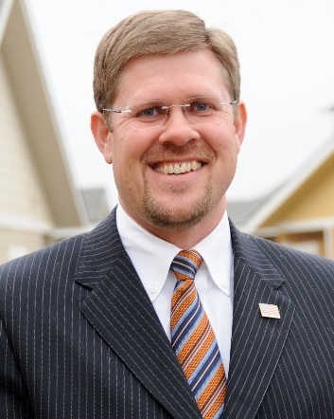She has been recognized locally as “Accomplished and Under 40” and one of Clark County's Most Interesting People. Ms. Topper is a graduate of Washington State University and holds a Master of Public Administration from Portland State University.

**Lowel Krueger** is the Executive Director of the Yakima and Kittitas County Housing Authorities. Before joining the Yakima Housing Authority in 2008, he was the chief financial officer for the Yakama Nation Housing Authority and an assistant state auditor.

In addition, Mr. Krueger serves the boards of the National Association of Housing and Redevelopment Officers, Association of Washington Housing Authorities, Impact Capital, and several housing-related councils in Yakima and Kittitas counties.

A lifelong resident of the Yakima Valley and a Certified Public Accountant, Mr. Krueger holds a bachelor’s degree from Central Washington University and a Master’s in Business Administration from Washington State University. He also completed the Senior Executives in State and Local Government program from Harvard University’s John F. Kennedy’s School of Government.

The two new Commissioners will vote in their first meeting next Thursday, July 27, at 1 p.m. at the Housing Finance Commission in downtown Seattle. The Commission will also honor outgoing two-term Commissioners Pam Tietz of the Spokane Housing Authority and Skamania County Assessor Gabe Spencer.

**####**

The [Washington State Housing Finance Commission](http://www.wshfc.org) is a publicly accountable, self-supporting team that brings private investment dollars to benefit families and achieve public goals throughout Washington. Since 1983, the Commission has created and preserved affordable homes for more than 350,000 people across the state, while billions of dollars and jobs to the economy.

[**@WSHFC**](http://www.twitter.com/WSHFC)



[**Facebook.com/WSHFC**](http://www.facebook.com/WSHFC)

